JAVA DAY -3

Encapsulation:

**encapsule+ capsule**

The process of Binding Code And Data together A Single entity(information).

Creating a structure of folders.

Data Hidden – Variable of class are hidden from other class

Polymorphism:

One task can be performed in many ways.

Poly - many

morphism - forms.

Types:

Method overloading🡪 Compile time poly/Static binding

Method overriding🡪 run time/dynamic

Method Overloading in Java:

In the Same Class the methods name will be same.

But Arguments (Or) Parameters will be different.

Depend Upon:

Class name: Emp_Det

Method 1 🡪 emp_Det(String a);

Method 2🡪 emp_Det(int b);

Method 3 🡪 emp_Det(char c, String d);

Method 4 🡪 emp_Det(char, String, int);

Classname obj=new Classname();

Obj.emp_Det(Capgemini);

Datatype 🡪 int

Datatype order 🡪int String

Datatype count 🡪int int int

It is Also Known as **Compile Time Polymorphism** or **Static Binding**.

Class A Class B

Method aB() Method aB()

Method Overriding:

* + - Class names are different but Methods name and Arguments names are same.
    - It is also known as Run Time **Polymorphism** or **Dynamic Binding**.

Rules for Java Method Overriding:

* + - The method must have the same name as in the parent class
    - The method must have the same parameter as in the parent class.
    - There must be an IS-A relationship (inheritance).

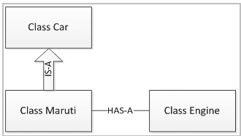

**Upcasting:**

Access a child class object to a parent class.

SYNTAX 2

Parent ClassName childclass_object=new ChildClassName();

* **Down casting:**

Access a parent class object to a child class. (Not possible in JAVA).

ChildClassName() parent_object=new Parent ClassName();

Inheritance:

Accessing one class property into another class using "**extends**" keyword

Relationship between parent class (super class) and the child class(sub class)

Single

One parent class accessed by one child class

Multiple:

Two parent class accessed by one child class

this method is not possible in java due to priority issues.

By using **INTERFACE**, we can overcome

Multilevel:

One parent class(a) is accessed by one child class(b) which is being accessed by another child class(c)

Grandfather🡪 father 🡪 son/dau

Hierarchical:

one parent more than one child

Hybrid:

combination of any two (single and multiple)

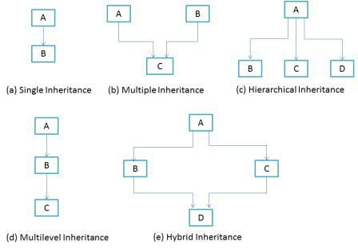

Control shift L🡪 Suggestion

Cntrl + Shift + Delete

Cntrl+Shift+F